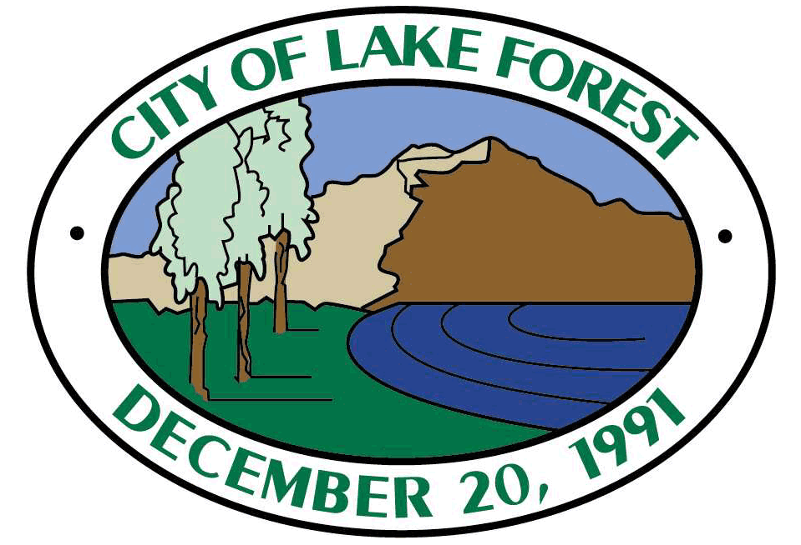
THIS IS A SAMPLE FORM AND SHOULD BE MODIFIED AS NECESSARY TO MEET THE NEEDS OF THE PARTICULAR PROJECT/CIRCUMSTANCE

[Date]
General Manager
ABC Water District/Agency/Company
123 Main St.
Anytown USA, xxxxx
Re: Water Supply Verification for ___________ Project within the City of Lake Forest
Dear M(r/s.) __________,
[Subdivision proponent] has submitted to the City of Lake Forest an application for tentative map (No. ## - ##) for the following subdivision ("Subdivision"):
[insert project description]
City staff has determined that the application is complete. Pursuant to Government Code section 66455.3, we are enclosing a copy of the application.]
[We have consulted with each other and have mutually agreed that your [District/Agency/Company] is a public water system that may provide water service to the Subdivision. We have also mutually agreed that the Subdivision is subject to the water supply verification requirements of the Subdivision Map Act.] Pursuant to Government Code section 66473.7(b)(1), the City requests [District/Agency/Company] to submit a water supply verification for the Subdivision on or before _______, ____, which is within 90 days of the date of this request. Please contact me to confirm receipt of this request.
Thank you for your cooperation in this matter. If you have any questions about this request, please contact me at your earliest convenience.

____________________________________
[Name]
[Title]

