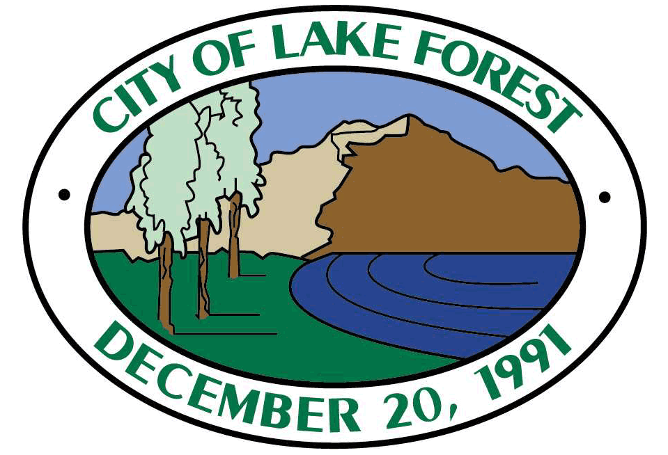
THIS IS A SAMPLE FORM AND SHOULD BE MODIFIED TO MEET THE NEEDS OF THE PARTICULAR PROJECT/CIRCUMSTANCE

[Date]
General Manager
ABC Water District/Agency/Company
123 Main St.
Anytown USA, xxxxx
Re: Water Supply Assessment for ______________ Project within the City of Lake Forest
Dear M(r/s.) __________,
We have received an application from [project proponent] for the following project (“Project”):
[list applications and briefly describe project]
We have consulted with each other and have mutually agreed that your [District/Agency/Company] is a public water system that may provide water service to the Project. We have also mutually agreed that the Project is subject to the water supply assessment requirements of Water Code sections 10910 - 10912. Pursuant to Water Code section 10910, the City requests [District/Agency/Company] to submit a water supply assessment for the Project on or before _______, ____, which is within 90 days of the date of this request. We concurrently request the [District/Agency/Company] to state whether the projected water demand associated with the Project was included as part of the City’s most recently adopted Urban Water Management Plan. Please contact me to confirm receipt of this request.
Thank you for your cooperation in this matter. If you have any questions about this request, please contact me at your earliest convenience.

____________________________________
[Name]
[Title]

