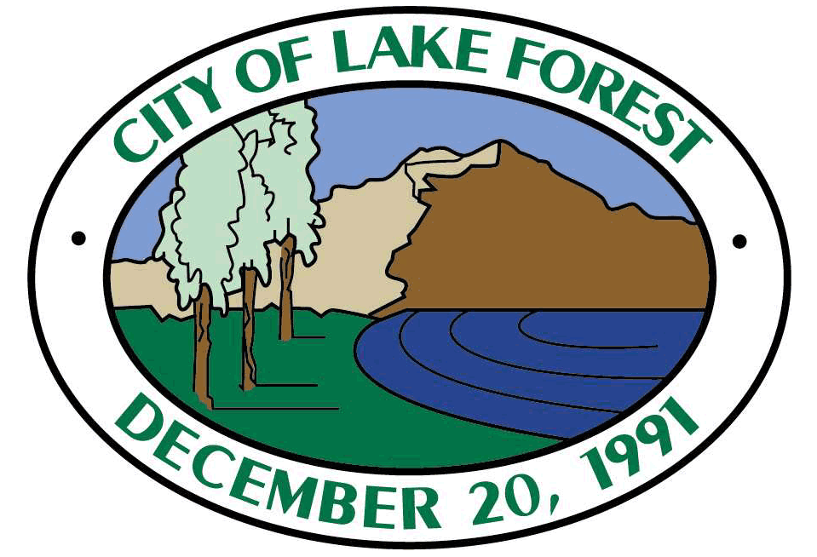

NOTICE OF AVAILABILITY OF DRAFT EIR

Project Title:
Project Location – Specific; Identify street address and cross streets or attach a map showing project site (preferably a USGS 15’ or 7 1/2’ topographical map identified by quadrangle name):
Project Location – City:
Project Location – County:
Description of Nature, Purpose, and Beneficiaries of Project:

Project Site – Specify if project site is included on any list of hazardous waste facilities:
Place and time of scheduled meetings:
Lead Agency:
Division
Date when project noticed to public:
Address where copy of the EIR is available and how it can be obtained in an electronic format:

Review Period: | [FILL- IN START DATE] to [FILL-IN END DATE]
Contact Person:
Contact Person’s Telephone (Area Code/Extension:

