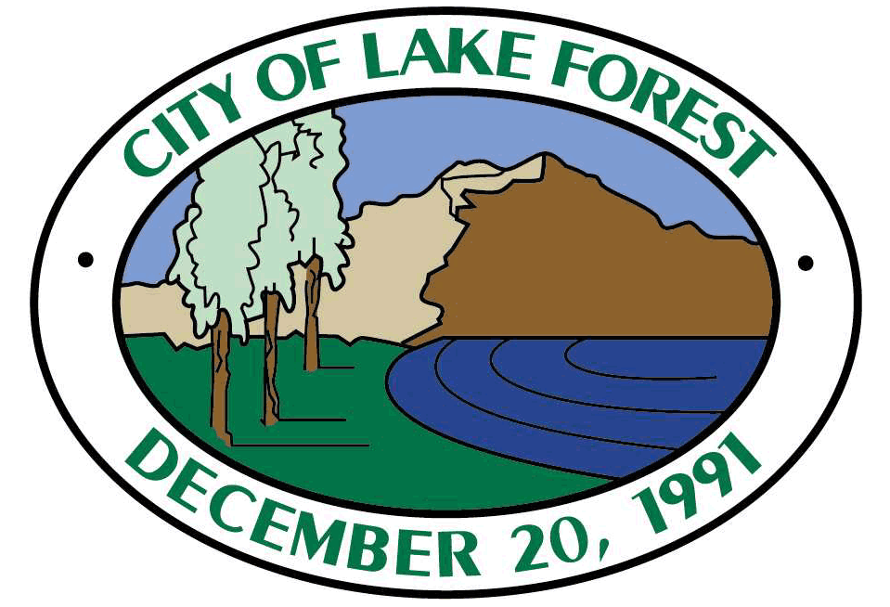

NOTICE OF INTENT TO ADOPT A NEGATIVE DECLARATION/
MITIGATED NEGATIVE DECLARATION
Notice is hereby given that the public agency named below has completed an Initial Study of the following described project at the following location:
Public Agency:
Project Name:
Project Description:
Project Location – Identify street address and cross streets or attach a map showing project site (preferably a USGS 15’ or 7 1/2’ topographical map identified by quadrangle name):
This Initial Study was completed in accordance with the Lead Agency’s Guidelines for Implementing the California Environmental Quality Act. This Initial Study was undertaken for the purpose of deciding whether the project may have a significant effect on the environment. On the basis of such Initial Study, the Lead Agency’s Staff has concluded that the project will not have a significant effect on the environment, and has therefore prepared a Draft Negative Declaration/Mitigated Negative Declaration. The Initial Study reflects the independent judgment of the Lead Agency.
The Project site IS on a list compiled pursuant to Government Code section 65962.5.
The Project site IS NOT on a list compiled pursuant to Government Code section 65962.5.
The proposed project IS considered a project of statewide, regional or areawide significance.
The proposed project IS NOT considered a project of statewide, regional or areawide significance.
The proposed project WILL affect highways or other facilities under the jurisdiction of the State Department of Transportation.
The proposed project WILL NOT affect highways or other facilities under the jurisdiction of the State Department of Transportation.
A scoping meeting WILL be held by the Lead Agency.
A scoping meeting WILL NOT be held by the Lead Agency.
If the project meets the criteria requiring the scoping meeting, or if the agency voluntarily elects to hold such a meeting, the date, time and location of the scoping meeting are as follows:
Date: |  | Time: | Location:
Copies of the Initial Study and Draft Negative Declaration/Mitigated Negative Declaration are on file and are available for public review at the Lead Agency’s office, located at:
The proposed Negative Declaration or Mitigated Negative Declaration can be obtained in electronic format by the following method:
Lead Agency address:
Comments will be received from [FILL-IN FIRST DAY OF COMMENT PERIOD] to [FILL-IN LAST DAY OF COMMENT PERIOD]
Any person wishing to comment on this matter must submit such comments, in writing, to the Lead Agency prior to [FILL-IN LAST DAY OF COMMENT PERIOD]. Comments of all Responsible Agencies are also requested.

The Lead Agency will consider the project and the Draft Negative Declaration/Mitigated Negative Declaration at its meeting on:
Date: | Time:
If the Lead Agency finds that the project will not have a significant effect on the environment, it may adopt the Negative Declaration/Mitigated Negative Declaration. This means that the Lead Agency may proceed to consider the project without the preparation of an Environmental Impact Report.

Date Received  for Filing: | Staff
(Clerk Stamp Here) | Title

